Stop Motion Animation

Homework Part 1

An Animation is a series of _________ (still pictures,) which are shown one after the other very fast. Due to __________________________ our eyes cannot keep up with the speed of change between each picture. This gives the impression that the characters in the frames are really moving and it brings the ____________ story to life.

persistence of vision frames animated

Stop motion animation is an animation ______________ to make an object to appear to move on it's own. The object is moved in _______ movements between _____________ photographed frames, creating the illusion of movement when the series of frames is played as a continuous ___________.

individually sequence technique small

Homework Part 2
Think of one idea for a simple stop motion animation based on a season.
Draw your idea like in the fly example below.
Ideas could be snow melting, leaves falling, sun rising, flowers opening, trees growing leaves etc.

Example:
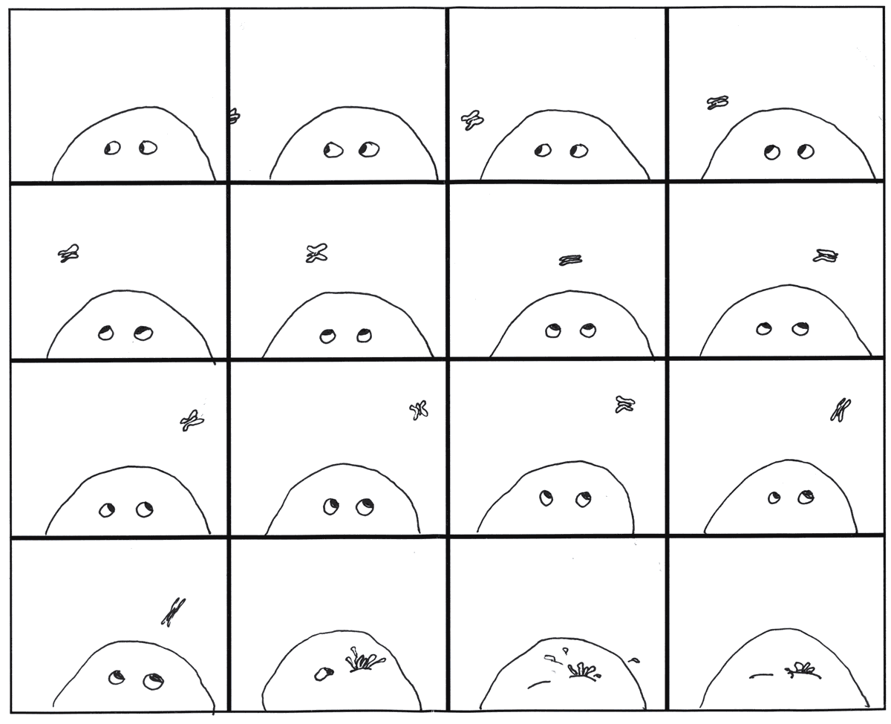

Frame for Stop Motion Idea

